Black-and-White Image Converter

# This program converts a color image (in PNG or JPG format) to a black-and-white (binary) image using a threshold. It also counts the number of black, white, and colored pixels in the image and displays these statistics.

# Features:

- Converts a color image to black and white (binary image).  
- Uses a threshold (default is 128) to determine whether each pixel is black or white.  
- Counts and displays the number of:  
- Black pixels in the converted image.  
- White pixels in the converted image.  
- Colored pixels in the original image.  
- Saves the converted black-and-white image to the specified location.

# Requirements:

- Python 3.x  
- Pillow library for image manipulation.  
Install Pillow by running: pip install pillow

* Install the app.exe to run it

# How to Use:

1. Download the script (image_converter.py) or an “.exe” file and place it in a folder on your computer.  
2. Run the script using the terminal.  
3. Input the file paths when prompted.  
4. The program will display the total number of pixels, black, white, and colored pixels.

# Code Structure:

convert_to_bw(image_path, output_path, threshold=128):  
 - Converts the image located at image_path to black and white using the specified threshold.  
 - Saves the black-and-white image at the location specified by output_path.  
 - Counts the number of black, white, and colored pixels and prints the results.

# Example:

Input:  
Enter the path to the input image: C:/Users/YourName/Pictures/sample_image.jpg  
Enter the path to save the output image: C:/Users/YourName/Pictures/output_image.jpg

Output:  
Total pixels: 2073600  
Black pixels in BW image: 1036800  
White pixels in BW image: 1036800  
Colored pixels in original image: 1520000

# Test Cases:

Test Case 1:  
Image: A colored image.

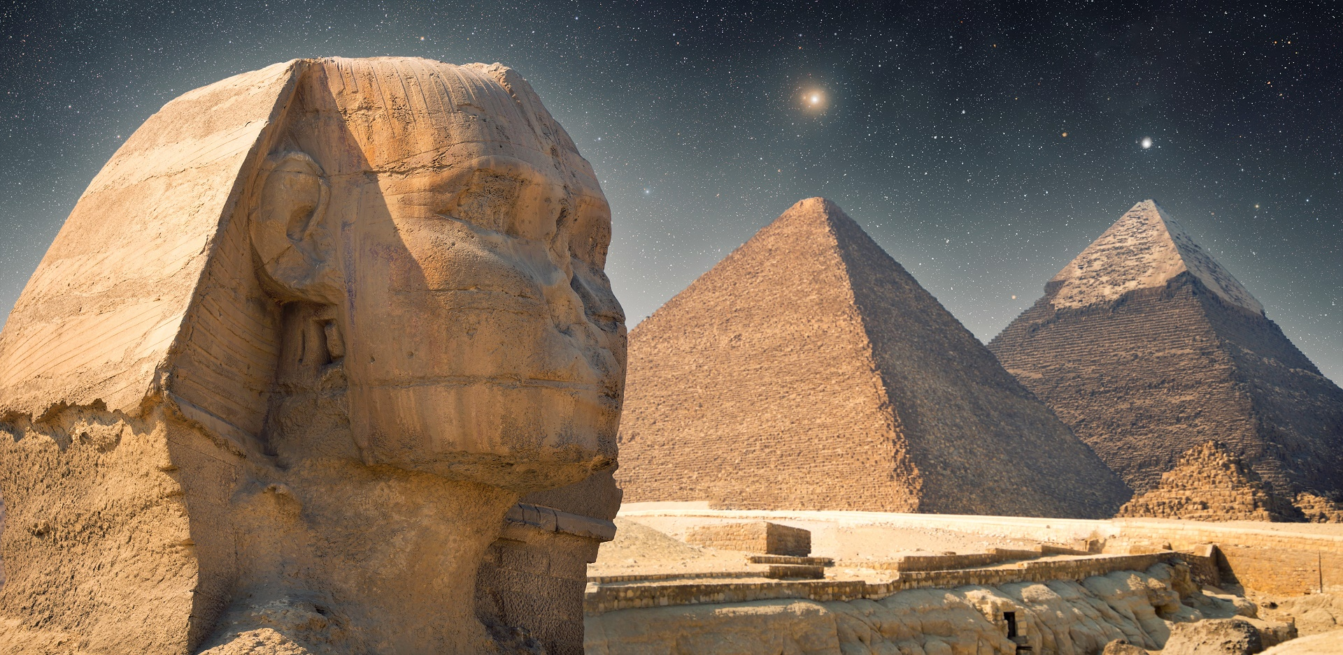

The Output:

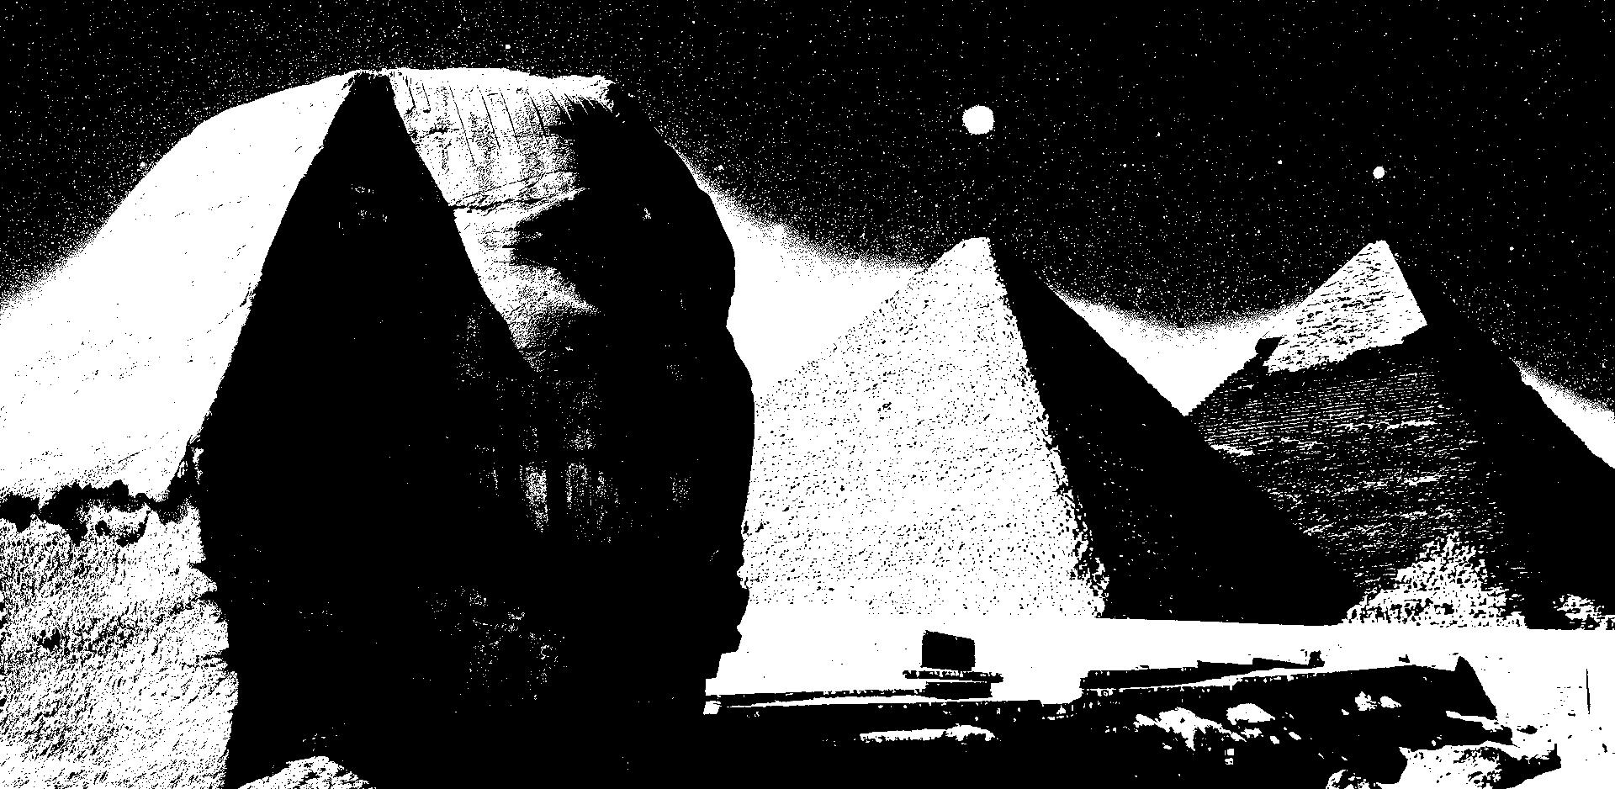

Expected Output: Varies based on color in the image.

Total pixels: 2073600

Black pixels in BW image: 1036800

White pixels in BW image: 1036800

Colored pixels in original image: 1520000

Test Case 2:  
Image: A colored image.

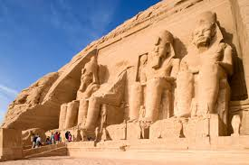

The Output:

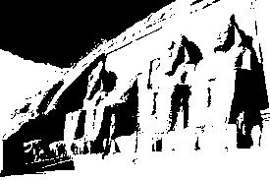

**Name**: Hager Tarek Saad Anter

**ID**:20230331943